# Inquiry lesson plan 4

|  |  |  |  |  |  |
| --- | --- | --- | --- | --- | --- |
| **Inquiry Title:** | Measures to reduce air pollution | **Lesson-** | 4 | **Date_** | 5th April |
| Name: | Vani Dewan | Subject(s): | Environmental Science | Grade: | 7th |

Inquiry Project Rationale & Overview

|  |
| --- |
| Why does this topic matter to students?  The adverse effects of air pollution need to be inculcated among students with the help from the teachers so that they remain well-aware of the situation from a younger age and take the necessary steps that can reduce the effect of air pollution to a greater extent. Through the Day 4 of the workshop, the students will be encouraged to discuss the controls measures for air pollution with their teacher so that they can contemplate on the previous learning and attempt to identify the possible solution on their own. This will help in creating self-awareness among the students on the growing concern about air pollution and compel them to make necessary changes in their daily life contributing to the cause.  **How does this lesson fit within the larger inquiry project?**  Discussion regarding the causes and impact of air pollution would be made. Discussion regarding the measures of controlling air pollution would be made. Discussion regarding the same factor would be made. All students and teachers would participate in the discussion in an effective way.  How does this project incorporate the inquiry cycle?  This is the lesson 4 of a four day workshop on the topic of reducing air pollution through which the teachers would attempt to inform the students about the measures that can be helpful in controlling air pollution and how the students from a young age can take part in smaller activities to bring the change that is necessary. The lesson would begin with a discussion on the topic which would further escalate into a reflective writing assignment that can help students in remembering the lessons that they have learnt throughout the workshop and their thoughts after the learning process. |

Key Questions for Inquiry About the Topic of Study

|  |  |
| --- | --- |
| Core Question | Supporting Questions |
| * What are the major causes of air pollution? * What are the measures that can control air pollution? * What changes can you implement on a daily basis to control air pollution? | * Are there any questions about the topic? |

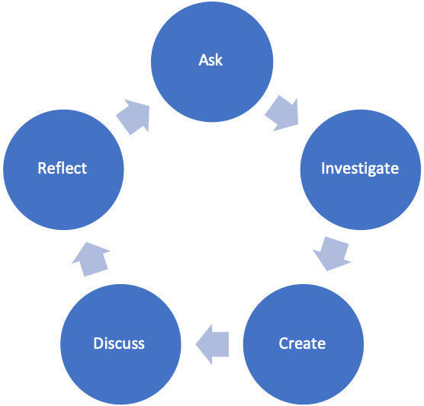

**Inquiry Approach/Style and Rationale**

|  |
| --- |
| An inquiry based learning approach has been adopted for this lesson through which the students will be encouraged to focus on the reduction of air pollution and demonstrate creative problem solving to reach meaningful conclusions. This will further build new knowledge and ideas by evaluating the topic and making connections between the learned aspects. |

Core Principles of Effective Teaching (Sharon Friesen)

|  |  |
| --- | --- |
| **Core Principle 1:** Effective teaching practice begins with the thoughtful and intentional design of learning that engages students intellectually and academically.  *\*\*How is the inquiry focused on building disciplinary knowledge and understandings?* | With the use of appropriate resources the knowledge of the students regarding the impact of air pollution and how it can be controlled to a considerable extent is the main aim of the teachers so that they can further explore the topic on their own. |
| **Core Principle 2:** The work that students are asked to undertake is worthy of their time and attention, is personally relevant, and deeply connected to the world in which they live.  *\*What makes this inquiry valuable, meaningful, and “alive” for the students and teachers?* | It can be said that most populations in the developing countries live in regions that have unsafe air (Zhang, Chen & Zhang, 2018). In order to encourage younger children to take part in the cause of reducing air pollution with the help of the experience and expertise of the teachers will result in positive outcomes. |
| **Core Principle 3:** Assessment practices are clearly focused on improving student learning and guiding teaching decisions and actions.  *\*How do I define learning and success in this inquiry? How is learning expressed and articulated in peer, self and teacher assessments?* | The learning process of the enquiry does not merely focus on what the students already know from the previous days of the workshop but concentrates on encouraging the students to apply their knowledge and reflect on it for future applications. |
| **Core Principle 4:** Teachers foster a variety of interdependent relationships in classrooms that promote learning and create a strong culture around learning.  *\*How do I connect students with each other, with experts in the field, with larger communities and nature, and across disciplines?* | The main goal and common functioning of an educational organization determines the educational environment integrity (Ilyashenko et al. 2019). Thus, with the creation of an educational environment teachers will create a strong learning culture regarding the topic. |
| **Core Principle 5:** Teachers improve their practice in the company of peers.  *\*How do I reflect on the inquiry together, and/or collaborate with others?* | Studies have concluded that professionals can learn and improve their performance by interacting with peers (Spillane, Shirrell & Adhikari, 2018). Learning from other’s experiences and expertise will help in improving their practices. |

BC Curriculum Core Competencies

|  |  |  |
| --- | --- | --- |
| Communication | Thinking | Personal & Social |
| * Application of the communication skills from practice. | * Application of creative thinking and problem solving skills. | * Application of responsible decision making. |

BC Curriculum Big Ideas (STUDENTS UNDERSTAND)

|  |
| --- |
| Air pollution adversely impacts all living beings including plants, animals and humans. Thus, it is necessary to implement the relevant measures to control air pollution. |

BC Curriculum Learning Standards

|  |  |
| --- | --- |
| **(STUDENTS DO)** | **(STUDENTS KNOW)** |
| Learning Standards - Curricular Competencies | Learning Standards - Content |
| [**Processing and analyzing data and information**](https://curriculum.gov.bc.ca/curriculum/science/11/environmental-science)   * Experience and interpret the local environment. * Analyze cause-and-effect relationships. * Construct, analyze, and interpret graphs, models, and/or diagrams.  [Applying and innovating](https://curriculum.gov.bc.ca/curriculum/science/11/environmental-science)  * Contribute to care for self, others, community, and world through individual or collaborative approaches. * Co-operatively design projects with local and/or global connections and applications. * Contribute to finding solutions to problems at a local and/or global level through inquiry. * Implement multiple strategies to solve problems in real-life, applied, and conceptual situations. | * Helping the students with writing the reflective content on the learning achieved through the workshop. |

Indigenous Connections/ First Peoples Principles of Learning

|  |
| --- |
| *How will I incorporate Indigenous knowledge and principles of learning?*  Drawing the attention of the students towards the core component of the topic which is the reduction of air pollution through allowing them to think over the entire learning process and express their views through the reflection. |

Respectful Relations

|  |
| --- |
| *How will I invite students of all backgrounds, interests and skills into the inquiry?*  Through the discussion regarding the measures of reducing air pollution each and every student’s perspective will be considered and elaborately discussed upon clearing the doubts and queries so that the students are not left out from the discussion. |

Project Overview

|  |  |  |  |
| --- | --- | --- | --- |
| Time Estimate | | Teacher and Student Activities | Assessment Activities |
| Ask | 1 hour | The students will be asked to recollect the learning from the previous days and remember the topic discussed. | Discussion on the previous knowledge and recollection. |
| Investigate | 2 hour | The students will be involved in group discussions and their thoughts will be discussed. | Group discussion on the control measures of air pollution. |
| Create | 2 hour | The students will be asked to write a reflective piece evaluating their experience from the entire workshop. | Writing reflection pieces in their copies. |
| Discuss | 1 hour | The students will be asked to discuss their writing pieces and their views will be considered for further evaluation. | Discussion on the reflective writing of the students. |
| Reflect | 1 hour | Evaluation of the views of the students on the reduction of air pollution. | Evaluation of the student perspective. |

Materials and Resources (use APA citation format)

|  |
| --- |
| * Project copies for writing the reflection. * Animated posters and clipart for demonstrating air pollution. * Information booklet for future use. |

Organizational Strategies (Optional)

|  |
| --- |
| Clearly explaining the impact and control measures of air pollution and encouraging the students to write the reflection report so that they can consider the challenges and understand the importance of implementing the measures. The methods of teaching are basically the application of theoretical findings (Setiyadi, 2020). |

Proactive, Positive Classroom Learning Environment Strategies (Optional)

|  |
| --- |
| Encouraging collaborative participation and discussion on the topic through promotion of the educational environment in the workshop. Communicative language teaching and learning in collaboration can be considered as the best method (Jabbarova, 2020). |

Reflections (to be completed after Project Completion)

|  |
| --- |
|  |

# References

Ilyashenko, L. K., Markova, S. M., Mironov, A. G., Vaganova, O. I., & Smirnova, Z. V. (2019). Educational environment as a development resource for the learning process. *Amazonia investiga*, *8*(18), 303-312.

Jabbarova, A. (2020). MODERN APPROACHES IN TEACHING SPEAKING. *Архив Научных Публикаций JSPI*, 1-5.

Setiyadi, A. (2020). Teaching English as a foreign language.

Spillane, J. P., Shirrell, M., & Adhikari, S. (2018). Constructing “experts” among peers: Educational infrastructure, test data, and teachers’ interactions about teaching. *Educational Evaluation and Policy Analysis*, *40*(4), 586-612.

Zhang, X., Chen, X., & Zhang, X. (2018). The impact of exposure to air pollution on cognitive performance. *Proceedings of the National Academy of Sciences*, *115*(37), 9193-9197.